Name ______________________________ Homework April 3-7
Put your initials by each night that your child practiced the following:
____Monday ____Tuesday ____Thursday
*Nightly Homework*
1. Read Start Right Reader page.
2. Count numbers 1-100.
3. Practice assigned Sight Word list in red reading folder.

Monday: Circle the vowels and underline the consonants in each word.
cat bug rag mug hat ten

hat ten pin hot leg on
Put the correct punctuation at the end of each sentence.
Do you see my pencil___ Can I go to the store _____
My hat is on the rack___ I like to slide _____
Stop, that is hot____ Whose paper is this ____

Tuesday: Write each spelling word three times.
dip lot yes tug wag
______ ______ ______ ______ ______

______ ______ ______ ______ ______

______ ______ ______ ______ ______

lid mud ham
______ _____ _______

______ ______ _______

______ ______ ______
Draw a line from the picture on the left to the picture on the right that rhymes.
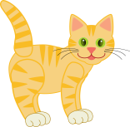

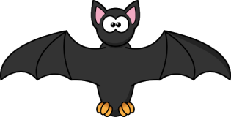

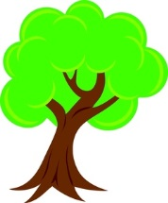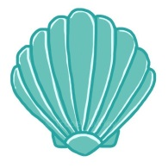
Thursday: Color the bee. Write 3 sentences about the bee. Include an upper case letter at the beginning, finger spaces beetween words, and correct punctuation.

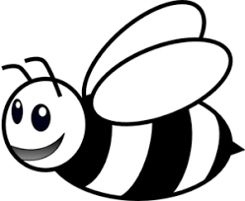

_____________________________________________________________

_____________________________________________________________

_____________________________________________________________
Blend the word together and draw a picture.
/d/ | /u/ | /ck/
/f/ | /i/ | /sh/

Start Right Reader Week of April 3-7
Directions: Let your child read this to you.

Words to Know
who your
well

Slug Must Nap
The sun is up, but Slug must nap. Where is your bed, Slug? Slug spots big sticks. “I can nap well here.” But a dog nabs them! “Well, I can nap in that big shell.” Tap! Tap! Tap! Tap! “Who is it? Slug? This is my bed, not your bed.” Slug hid in a pot. But kids got it! Then Slug spots a rock. Who can snag it? Slug can! Slug naps at last.

Comprehension Questions: (Parents, ask your child the questions about the story.)
What does Slug want to do? Where does Slug try to nap first? Why can’t he nap there? Where does Slug finally nap?

Blend and Read: Read these words. Find these words in the story.
then that where
shell snag well
rock spots must
nabs naps tap

Initial each night.
Mon. | Tues. | Thurs.

